Case 5-Asia-China-Huanghuali Wood Writing Box- Ming Dynasty (1368-1644),

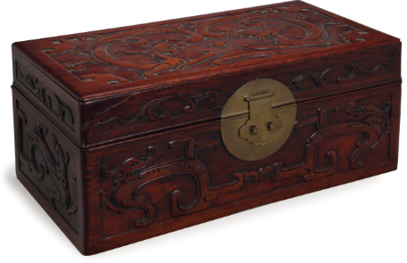

Fig. 1. A000-Asia-China-Huanghuali Wood Writing Box- Ming Dynasty (1368-1644),

**Case no.: 5**

**Accession Number:**

**Formal Label:** Huanghuali Wood Writing Box- Ming Dynasty (1368-1644),

**Display Description:**

The Chinese term *huanghuali* literally means "yellow flowering pear" wood. It is a member of the rosewood family and is botanically classified as *Dalbergia odorifera*. In premodern times the wood was know as *huali* or *hualu*. The modifier *huang* (yellowish-brown) was added in the early twentieth century to describe old *huali* wood whose surfaces had mellowed to a yellowish tone due to long exposure to light. The sweet fragrance of *huali* distinguishes it from the similar appearing but pungent-odored *hongmu*.

So rare that it rivals gems and precious metals in value, huanghuali, a type of rosewood, was among the tropical hardwoods found in old-growth forests in the extreme south of the Chinese Empire.

In the 16th and 17th centuries, toward the end of the great Ming Dynasty (1368-1644), the highly desirable wood was used for elegant furniture forms – boxes, chairs, stools, tables and graceful canopy beds.

In the 21st century, genuine Ming huanghuali designs have been keenly sought after, especially by wealthy Asian collectors. Adding to the market scramble is that fact that many of the best pieces have long been ensconced in the permanent collections of major museums, East and West.

**LC Classification:**

**Date or Time Horizon:** Ming Dynasty (1368-1644),

**Geographical Area:** Hainan. Island

**Map:**

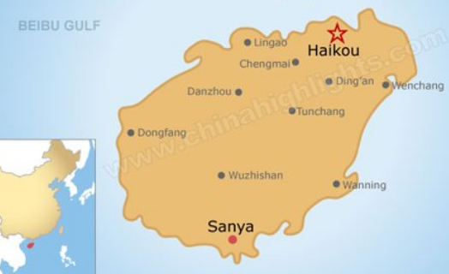

**Fig.Map of Hainan Island after https://images.chinahighlights.com/allpicture/2015/04/b164f4a825eb4788b2a46c27_528x353.jpg**

**GPS coordinates: Sanya:** [18°15′12″N 109°30′13″E](https://tools.wmflabs.org/geohack/geohack.php?pagename=Sanya&params=18_15_12_N_109_30_13_E_region:CN-46_type:city(685408))

**Cultural Affiliation:** Ming

**Medium:** Huanghuali wood from Hainan.

**Dimensions:**

**Weight:**

**Condition: original**

**Provenance:**

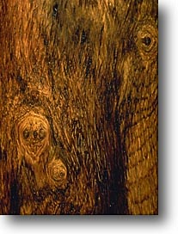This huanghuali box is an ancient piece from the Ming Dynasty that has been in the family for generations as the great uncle of the grandmother of the present owner, Morris Jacobsen, who was a Swedish mariner who brought this back from China in the early 20th c.

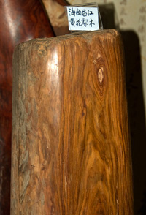

**Discussion: *Dalbergia odorifera***, or **fragrant rosewood**[[3]](https://en.wikipedia.org/wiki/Dalbergia_odorifera#cite_note-ars-3) (降香黄檀; *jiàngxiāng huángtán*; literally: desert incense sandalwood, is a species of [legume](https://en.wikipedia.org/wiki/Legume) in the [Fabaceae](https://en.wikipedia.org/wiki/Fabaceae) family. It is a small or medium-sized tree, 10–15 metres (33–49 ft) tall.[[4]](https://en.wikipedia.org/wiki/Dalbergia_odorifera#cite_note-eflora-4) It is endemic to China and occurs in [Fujian](https://en.wikipedia.org/wiki/Fujian), [Hainan](https://en.wikipedia.org/wiki/Hainan), [Zhejiang](https://en.wikipedia.org/wiki/Zhejiang),[[4]](https://en.wikipedia.org/wiki/Dalbergia_odorifera#cite_note-eflora-4) and [Guangdong](https://en.wikipedia.org/wiki/Guangdong).[[5]](https://en.wikipedia.org/wiki/Dalbergia_odorifera#cite_note-Furniture-5) It is used as a wood product and in folk medicine.[[3]](https://en.wikipedia.org/wiki/Dalbergia_odorifera#cite_note-ars-3) This valuable wood is known in China as *Huali* and *Huanghuali*.[[5]](https://en.wikipedia.org/wiki/Dalbergia_odorifera#cite_note-Furniture-5) Higher quality furniture from the late [Ming](https://en.wikipedia.org/wiki/Ming_Dynasty) and early [Qing](https://en.wikipedia.org/wiki/Qing_Dynasty) dynasties were made of this wood.[[5]](https://en.wikipedia.org/wiki/Dalbergia_odorifera#cite_note-Furniture-5) *Huanghuali* from Changjiang, Hainan. .

Four compounds isolated from the root of this plant have been shown in a laboratory to have antioxidant properties (Chen, Zhang and Larsen 2001; Yu, Wang, Yang 2007).

|  |
| --- |
| The finest *huanghuali* as in our example has a translucent shimmering surface that is highly prized.  The color can range from reddish-brown to golden-yellow. Historical references point to Hainan Island as  the main source of *huali*. However, variations in the color, figure, and density suggest similar species  sourced throughout North Vietnam, Guangxi, Indochina and the other isles of the South China Sea. |
|  |
|  |

**References:**

Chen, Dezhao; Dianxiang Zhang and Kai Larsen. 1963. ["Dalbergia odorifera*"*](http://www.efloras.org/florataxon.aspx?flora_id=2&taxon_id=242316792). *Acta Phytotax. Sin*. 8: 351.*.* http://www.efloras.org/florataxon.aspx?flora_id=2&taxon_id=242316792 Retrieved 30 Jan 2018.

Yu, X.; Wang, W.; Yang, M. (2007). "Antioxidant activities of compounds isolated from Dalbergia odorifera T. Chen and their inhibition effects on the decrease of glutathione level of rat lens induced by UV irradiation," *Food Chemistry* 104 (2): 715–720.

**Appendix:**

**Christie’s auction:** Sale 2667 Christie's Interiors, 8 - 9 January 2013, New York

[**http://www.christies.com/lotfinder/Lot/a-chinese-carved-huanghuali-box-and-cover-5646337-details.aspx**](http://www.christies.com/lotfinder/Lot/a-chinese-carved-huanghuali-box-and-cover-5646337-details.aspx)

A CHINESE CARVED HUANGHUALI BOX AND COVER,   
carved with confronting dragons and other stylized symbols, components possibly later assembled  
14in. (35.5cm.) long

Estimate USD 2,500 - USD 3,500  
Price realised USD 47,500



##### **Contact Client Service**

* [info@christies.com](mailto:info@christies.com)
* New York +1 212 636 2000